**Procedural Programming Assignment No. 1(B)**

**Name : Tejas Waghmare**

**Roll no. : 72**

**Div : N**

**Aim :** To write an algorithm and pseudo code for simple and complex problems.

**Algorithm:**

Step 1 : Start

Step 2 : Declare variables A,B and C

Step 3 : Enter the two numbers

Step 4 : Perform additions of two nos. C = A+B

Step 5 : Display sum/addition/result Step 6 : Stop

**Pseudocode:**

Begin

Declare Variables A,B and C

Read A, B

Calculate C = A+B

Display “Sum of two numbers is C”

End

**Code/Program:**

#include<stdio.h> int main()

{

int a=10; int b=10; int c; c=a+b; printf(“Sum is:%d”,c); return 0;

}

**Output:**

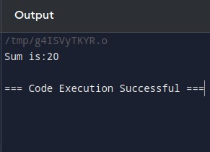

**Flowchart:**

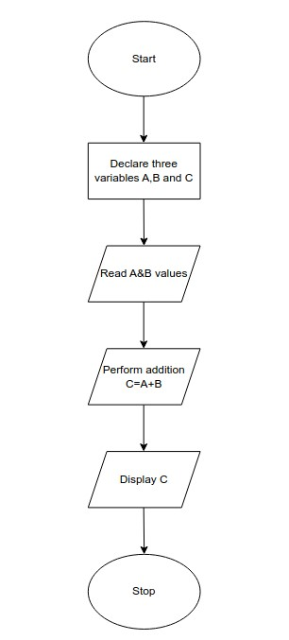

**Conclusion:**

Thus we have completed an algorithm and pseudo code for simple and complex problems